

Disciplinary Measures Guideline
The following guidelines provide a high-level breakdown of common disciplinary measures and processes. These include:
- Verbal warning
- Written warning
- Performance Correction Action Plan
- Suspension, probation, demotion
- Dismissal
Depending on the severity of the situation, you may choose not to follow these steps in order, but rather to jump straight to more severe disciplinary measures.
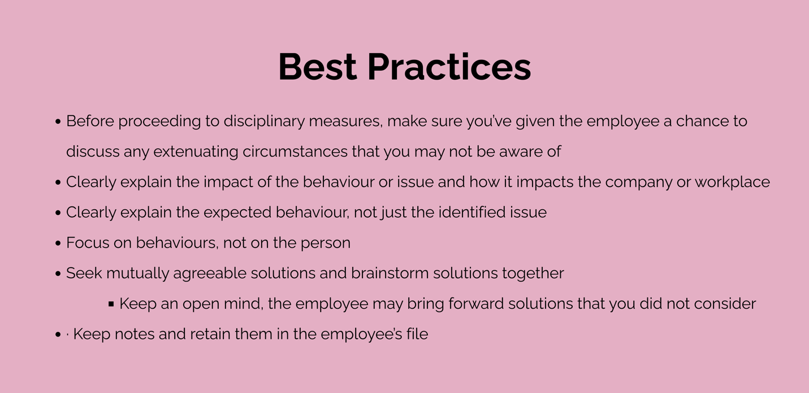

Verbal Warning
If a performance issue or unacceptable behaviour is identified, generally, the first disciplinary measure taken is giving a formal verbal warning. However, assuming the issue is not severe in nature, the formal verbal warning should only be performed following informal corrective action taken by trainers or managers.
- Book a private meeting with the employee to discuss the issue
  - Avoid giving verbal warnings in a public setting where possible. For example, safety concerns or immediate instructions to prevent manufacturing or production defect may require a public verbal warning.
- Come prepared to discuss the issue
  - Have all the details and facts on hand
  - Have a copy of any relevant company documentation (e.g., policies, instruction manuals, training materials)
- In the meeting, clearly state that you are issuing a formal verbal warning
  - Describe in detail the performance issue identified or the unacceptable behaviour referencing relevant company documentation
- Discuss and brainstorm with the employee how they can modify their behaviour in response to the identified issue
  - Provide the employee with a copy of all relevant company documentation

5. Record what occurred in the meeting or during the verbal warning using the Verbal Warning Acknowledgement Template below

Verbal Warning Acknowledgement
Employee name:
Date:
Identified Issue:
I acknowledge that I received a formal verbal warning regarding the issue above.
Employee Name: _______________________________________
Employee Signature: ____________________________________ | Date: ____________
Manager Name: _______________________________________
Manager Signature: ____________________________________ | Date: ____________

Written Warning
If the issue persists, you may choose to issue a written warning. More than one written warning can be issued before moving to the Performance Correction Action Plan depending on the severity of the issue.
1. Fill out the Disciplinary Letter Template below
2. Book a private meeting with the employee
3. Clearly state that you are issuing a written warning and read the prepared Disciplinary Letter during the meeting
4. Provide the employee with a copy of the Disciplinary letter
- Discuss and brainstorm with the employee how they can modify their behaviour in response to the identified issue
  - Provide the employee with a copy of all relevant company documentation
  - Emphasize any existing solutions, such as those discussed during the verbal warning stage, as applicable
6. Record the written warning occurrence using the Written Warning Acknowledgement Template below

Disciplinary Letter
Date:
Employee name:

Re: Written warning

[Name of employee],

The purpose of this letter is to advise you that [describe the issue].

[Use this sentence if a verbal warning was issued] In a one-on-one meeting with you on [month, day, year], your manager clearly outlined the company’s expectations with you regarding this issue. Given that the issue persists, this is a formal written warning.

[Use this sentence if a verbal warning was not issued] Due to the severity and nature of the situation, this written warning has been issued to you.

Please be advised that another misdemeanour, depending on its severity, may result in the creation of a Performance Correction Action Plan, suspension, probation, demotion, and/or dismissal.

Sincerely,

(Signature)
Name
Job title
Name of organization

Written Warning Acknowledgement
Employee name:
Date:
Identified Issue:
Copy of Disciplinary Letter
Date:
Employee name:

Re: Written warning

[Name of employee],

The purpose of this letter is to advise you that [describe the issue].

[Use this sentence if a verbal warning was issued] In a one-on-one meeting with you on [month, day, year], your manager clearly outlined the company’s expectations with you regarding this issue. Given that the issue persists, this is a formal written warning.

[Use this sentence if a verbal warning was not issued] Due to the severity and nature of the situation, this written warning has been issued to you.

Please be advised that another misdemeanour, depending on its severity, may result in the creation of a Performance Correction Action Plan, suspension, probation, demotion, and/or dismissal.

Sincerely,

(Signature)
Name
Job title
Name of organization
I acknowledge that I received a formal written warning regarding the issue above and was provided a copy of the disciplinary letter.
Employee Name: _______________________________________
Employee Signature: ____________________________________ | Date: ____________
Manager Name: _______________________________________
Manager Signature: _____________________________________ | Date: ____________

Performance Correction Action Plan
Either concurrently with a written warning or as a next step if issues persist, a Performance Correction Action Plan should be put in place. Where possible, the employee and manager should collaborate to identify actions that can be taken to address the issue.
The template below can support this step.

Performance Correction Action Plan
Employee name:
Date:

Identified Issue:
List of previously provided formal verbal and written warnings, include the dates issued:

Action Plan to Address Issue
Action  Actions should refer to company documentation where applicable. They can include additional training or development activities. | Target Start Date  e.g., a corrective training session may not have an immediate start date versus a change in process or behaviour could start immediately
The success of these actions in correcting the issue will be assessed on [Month, Day, Year].

I acknowledge that I have been placed on a Performance Correction Action Plan and commit to actively correcting the identified issue by performing the identified actions.
Employee Name: _______________________________________
Employee Signature: ___________________________________ | Date: ____________
Manager Name: _______________________________________
Manager Signature: _____________________________________ | Date: ____________

Suspension, Probation, Demotion
If issues persist after one or more written warnings, a suspension, probation, or demotion may be warranted. Depending on the severity of the situation, you may choose to skip the steps above and proceed with a suspension, probation, or demotion.
The employee should be notified as soon as possible in a written format of the decision. Preferably, this would be done via email to have a date and time stamp on the document. Alternatively, the provision of the letter to the employee in hard copy should be witnessed by another company representation (e.g., another manager, human resources representative).
This letter should state:
- The issue identified
- A list of verbal and written warnings previously provided
- The decision made regarding suspension, probation, or demotion
- A clear warning that a continuation of the behaviour may result in the termination of their employment
A meeting should then be held with the employee to discuss the issued letter. It is recommended that more than one company representative be present at the meeting (e.g., manager and human resources representative).
Dismissal
If an employee fails to correct his or her unacceptable behaviour even after all other recourses have been exhausted, dismissal of the employee for just cause may be appropriate.

